FACT SHEET May 2026
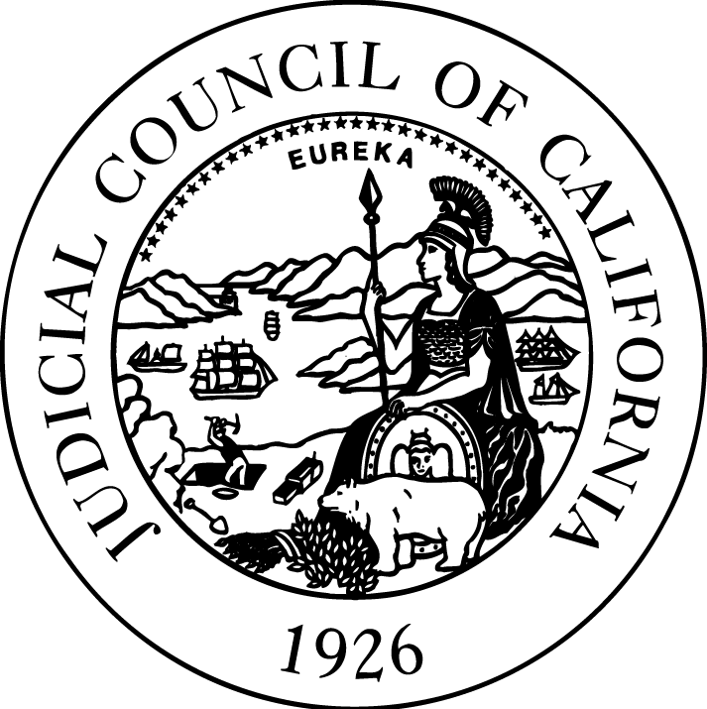

JUDICIAL COUNCIL
OF CALIFORNIA
455 Golden Gate Avenue
San Francisco, CA
94102-3688
Tel 415-865-4200
TDD 415-865-4272
Fax 415-865-4205
www.courts.ca.gov

New Hall of Justice — Sonoma County Courthouse
Located at 625 Administration Drive in Santa Rosa, the new Hall of Justice consolidates court services, and addresses overcrowding and security issues. The court expects to officially open the new courthouse for business this summer.
New Courthouse Consolidates and Improves Services
The new courthouse will provide a modern, secure facility of 15 courtrooms and 167,147 square feet. It will consolidate in one location all criminal, traffic, juvenile dependency, and probate proceedings as well as family court mediation and probate investigative services and enhanced drug court support. It also includes features and services that the court was previously unable to provide due to space restrictions, such as appropriately sized jury assembly and deliberation rooms, adequately sized in-custody holding, attorney interview/witness waiting rooms, a children's waiting room, and security entrance screening of all court users.
The Building Is Energy Efficient
The building’s sustainability features are built to LEED Silver as designated by the U.S. Green Building Council. This is a third-party certification program and the nationally accepted benchmark for the design, construction, and operation of high-performance “green” buildings. The courthouse’s sustainability features include drought-tolerant landscaping, water-efficient irrigation and plumbing systems, and energy-efficient lighting.
Community Input into New Courthouse
A broad-based Project Advisory Group for the courthouse project was composed of community, legal, and government leaders, which included representatives from the court and Public Works. The group provided input throughout the site selection and design process. In addition, public input was a part of the environmental review process.
Part of a Statewide Courthouse Construction Program
Since the state’s judicial branch assumed responsibility for court construction and maintenance in 2002, the branch has completed 39 new courthouse projects and 14 are currently under way. These include new court facilities in both large and small counties, as well as urban and rural areas across the state.

More Information
Contact:
Blaine Corren, Judicial Council Public Affairs, 415-865-7449, blaine.corren@jud.ca.gov
Additional resources:
Project webpage, courts.ca.gov/facilities/sonoma-county-new-hall-justice
California Courts Newsroom, newsroom.courts.ca.gov/

