FACT SHEET April 2024
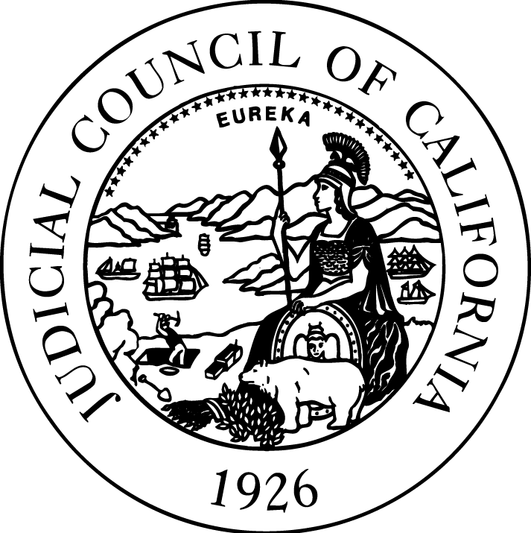

JUDICIAL COUNCIL
OF CALIFORNIA
455 Golden Gate Avenue
San Francisco, CA
94102-3688
Tel 415-865-4200
TDD 415-865-4272
Fax 415-865-4205
www.courts.ca.gov

New Shasta County Courthouse in Redding
Construction of the new Shasta County Courthouse began in 2019 and officially opened for business on February 12, 2024. Located at 1515 Court Street, the new building consolidates court services and addresses overcrowding, security, and accessibility issues.
New Courthouse Consolidates and Improves Services
The new courthouse has 14 courtrooms, consolidating adult and juvenile court services for residents of Shasta County. The new courthouse features jury deliberation rooms, a self-help center, attorney/client conference rooms, and ADA accessibility. Enhanced security features include entrance screening of all court users, a secure sallyport and in-custody holding, and improved fire and life safety systems.
The Building Is Energy Efficient
The building’s sustainability features are built to LEED Silver as designated by the U.S. Green Building Council. This is a third-party certification program and the nationally accepted benchmark for the design, construction, and operation of high-performance “green” buildings. The courthouse’s sustainability features include drought-tolerant landscaping, water-efficient irrigation and plumbing systems, and energy-efficient lighting.
Community Input into New Courthouse
A broad-based Project Advisory Group for the courthouse project was composed of community, legal, and government leaders, which included representatives from the court and Public Works. The group provided input throughout the site selection and design process. In addition, public input was a part of the environmental review process.
Part of a Statewide Courthouse Construction Program
The courthouse was ranked as an “Immediate Need” in the judicial branch’s capital-outlay plan, making it among the branch’s highest-priority infrastructure projects. Since the state’s judicial branch assumed responsibility for court construction and maintenance in 2002, the branch has completed 35 new courthouse projects and 18 are currently under way. These include new court facilities in both large and small counties, as well as urban and rural areas across the state.

More Information
Contact:
Blaine Corren, Judicial Council Public Affairs, 415-865-7449, blaine.corren@jud.ca.gov
Additional resources:
Project webpage, https://www.courts.ca.gov/facilities-shasta.htm
California Courts Newsroom, http://newsroom.courts.ca.gov/

